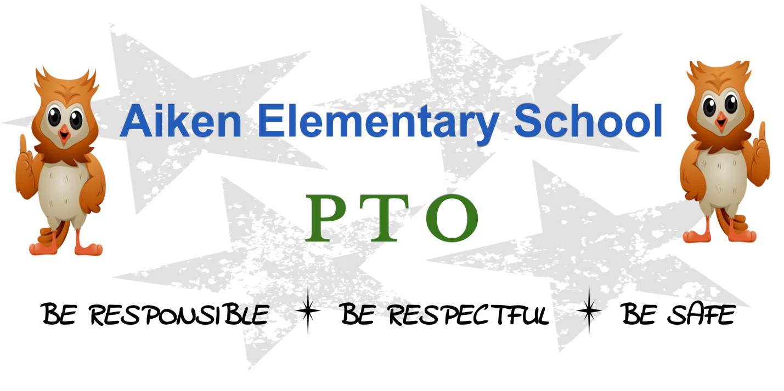

Hello Aiken Families,

We are so excited to welcome back our returning families and to meet our incoming students and families. We hope that everyone had an amazing summer and that you’re ready for a great year at Aiken!

The Aiken PTO’s mission is to aid the students at Aiken Elementary School by providing support for their educational and recreational needs, and to promote open communication between the administration, teachers and parents. At the end of the day, we are a community, and we want to ensure that all of our families, teachers and administrators are supported and recognized.

Aiken PTO Board Members

We are excited to introduce you to our Aiken PTO Officers for the 2022-23 school year:

Co-Presidents: Adrienne Billings-Smith & Julie Cutler
Co-Vice Presidents: Tina Palmieri & Abiah Ruel
Co-Secretaries: Jen Johnson & Corie Tracey
Co-Treasurers: Carmina Mio & Susie Billings-Smith*
Fundraising: Amanda Pihl & Sabrina Beauliue
Community Outreach: Astraea Augsberger & Libby Greenblatt
PNO Chair: OPEN

Principal and Teacher Representatives: Shannon Mlodzinski, Kelly Young & Allison Bohle

Committee/Volunteer Opportunities

We are always looking for volunteers to be part of the events that help achieve our mission:

5th Grade Committee
Parent’s Night Out Chair & Committee (May 2023)
Room Parent Volunteers
Pizza Bingo Volunteers
Garden Club Volunteers & More

Please contact AikenPTOVolunteers@gmail.com or AikenPTO@gmail.com for more information.

COMMUNICATION IS KEY!

In order to stay connected we send weekly newsletters with important information that is going on in the Aiken and West Hartford Community through Konstella (https://www.konstella.com). Please make sure you register as soon as possible so that you don’t miss out on events, volunteer opportunities, and school updates. You can also find information on our Aiken PTO Facebook page and our Aiken PTO website (www.aikenpto.org).

Upcoming Events*:

Mark your calendars and join us for these beginning of the school year events:

Parents’ Back to School Bash
When: TBA 7:00 PM-10:00 PM
Where: TBA
Tickets: $25 (includes 2 drink tickets)
Register through PayPal: DonatetoAiken@gmail.com

First Day of School Coffee Social
When: August 31, 2021
Where: Aiken (outdoor area)
Time: 9 AM

Aiken PTO Kick-off Meeting
When: TBA, 2022
Where: Aiken Cafeteria (possibly hybrid)
Time: 7 PM

*Events are subject to change based on health and safety guidelines*

Again, we are looking forward to a great school year, full of great activities and building a strong and supportive community for our Aiken students and families.

If you have any questions or concerns, please contact us at aikenpto@gmail.com.

Sincerely,

Adrienne and Julie

